Worksheet
Skills for positive communication
A mentally healthy workplace is mana-enhancing. The Māori concept of mana includes many things. In this worksheet it refers to dignity, respect, power and prestige. Mana-enhancing is about having a safe environment that enables mutual respect and people’s inherent worth and value is expressed and encouraged. Positive or mana-enhancing communication closes the space between different understandings, while building trust and mutual respect.

Four practical ways you can shift to positive, mana-enhancing communication are:
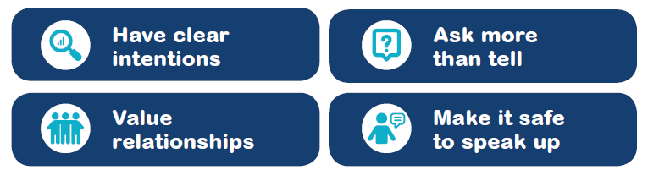

Principles of building psychological safety in communication:
• Based on respect • Value honesty, build trust • Open communication
• Make it safe to show vulnerability • Information sharing

Activity:
- Think about when you interact with others in your team or in other parts of your life.
  - What do people do that helps build positive, mana-enhancing communication?
  - How do you show others respect and trust?
- Now take some time (individually or in groups) to describe what you think positive communication looks like at work (words – conversations, emails, texts – actions, body language, etc):

What is happening when I feel: |  | What do I do to help others feel?
Comfortable & Safe
Respect/respected

Trust/trusted

Valued

- Below are some skills that support positive communication. From your description of positive communication, highlight which attributes and skills:
  - Are being used now to support good communication in your workplace
  - Could be strengthened to support good communication in your workplace

Attributes | Skills
Approachable and accessible | - Effective listening (includes empathetic body language - eye contact, gestures, facial expressions)  - Asking helpful questions  - Validating employee efforts and opinions  - Paraphrasing to check understanding  - Asking for understanding and confirmation of message  - Transparency and information sharing  - Following through on promises
Show humility | - Self-awareness and understanding of own communication style  - Acknowledge own fallibility  - Assess what you don’t know – let curiosity guide you and accept the need for others’ input
Openness with communication | - Give clarity around goals, expectations and responsibilities  - Explain why a decision was made  - Communicate in a timely manner  - Important information flows continuously – people know what they need to know – there are no surprises  - Share information that people need to do their jobs  - Explain change and specific implications of change  - Validate (acknowledge/thank) other people’s responses
Proactively invite input | - Give and receive feedback  - Encourage and seek questions, suggestions and opinions  - Welcome and consider all views  - Be open to honest, useful criticism
Tolerance and consistency | - Avoid blaming and shaming – encourage learning from mistakes and disappointments  - Fairness in dealing with people  - Clarity in what behaviours are acceptable and what will happen when rules are broken
All staff are valued | - Personalise relationships – acknowledge the other person as a whole person, not just a role

