Worksheet
Positive work environments matrix

 | What do we need? | What are the barriers?
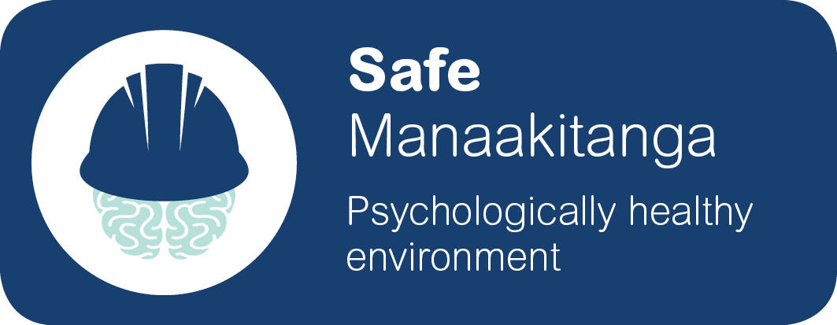

Safe from things that impact negatively on mental health and wellbeing

Supportive when people are struggling with life challenges

Strengthen peoples’ skills and knowledge to attain optimal mental wellbeing
Discussion instructions:
In pairs (or small groups) discuss what you think we need to have a positive work environment that is safe, supportive and strengthens our mental wellbeing, and identify any barriers that may exist.

This will help us identify what we may already be doing well and where we can make improvements to support mental wellbeing at work.

In pairs or small groups:

- Think about our work (how it is done, when and where and with who).
- Think about what is needed (in your experience) for you to feel good, get the job done well and have supportive and positive relationships with your team.
- You have 5 mins to have a look at the ‘Positive work environments matrix’ and discuss then write down some of the things our organisation needs (or is doing) to create positive work environments.
- Then take 5 mins to talk about some of the challenges or barriers faced to achieving a mentally healthy workplace. Write down these on the worksheet too.
- Agree on one idea that might make the biggest difference to our workplace.
- Allocate one person to speak about this idea.
- Each group will then share back to the main group.

This worksheet can be used to help set priorities for planning and to check on progress.

