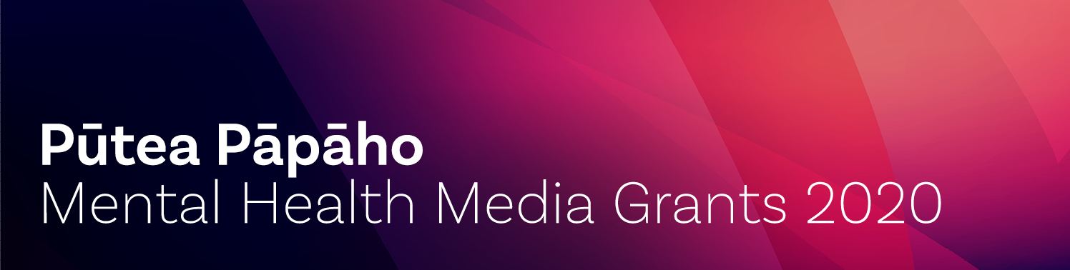
Pūrongo | Journalism Application Form

Applications must include the following:
- A completed application form
- A written or filmed project proposal which talks to one of the Journalism grant themes.
If you are submitting a written proposal it must be no more than 1,500 words long; if submitting a video proposal, it must be no more than 10 minutes long and hosted on an external platform such as YouTube or Vimeo.
Your written or filmed project proposal should:
  - Explain your reasons for applying
  - Describe your project in detail – what you intend doing, when and where
  - Explain how the project will help to patua te whakamā/lift the shame, social exclusion and judgement that people with mental distress can face
  - Identify potential sources and angles, and what messages you will be aiming to communicate
  - Indicate how people with mental distress and their whānau will be consulted and involved in the project
  - Identify your planned audience and explain how the project will be promoted to that audience
  - Outline what impact you expect from the project and how you will know it has been a success.
- A realistic budget within the maximum funding of the grant ($10,000). If you require additional funding for your project, you will need to include proof you have secured this funding.
- Written expressions of interest from outlets or other organisations in New Zealand confirming they have knowledge of the project and have a genuine interest in publishing or broadcasting the finished project.
- Your curriculum vitae/resume detailing your education and employment history as well as any major professional achievements.
- Up to three recent examples of your work, with at least one of the samples from the media proposed for the project. Please do not send original materials in support of your application, as they will not be returned.
- Three references from individuals, who are supportive of your project, are familiar with your skills and experience, and can comment on your abilities and potential.
If shortlisted for a grant, you may be requested to supply:
- Examples of published work. Please do not send original materials in support of your application, as they will not be returned.

Scroll down to complete the application form.

Pūrongo | Journalism Application Form
Applications must be received by 5pm, Friday 9 October 2020, at the following email address:
Email: journalism@mediagrants.org.nz (subject line: ATTN: NZ Mental Health Journalism Grants).
Due to the physical restrictions surrounding COVID-19, submitting your application by email is recommended. If you need to hand deliver or courier your application, please email journalism@mediagrants.org.nz to arrange a physical submission in advance.
The Mental Health Foundation will not accept any responsibility for lost or late applications.
Name:
Address:

Email address:
Phone: |  | Mobile:
Please indicate which theme your application fits under:
What’s it like? Experiences within New Zealand’s mental health system
Mental distress and COVID-19
Busting the myths
The identities that make us: Intersectionality and mental distress
Culturally speaking: Perceptions of mental distress from a te ao Māori worldview
Workplaces
Please choose which of the following describes you (tick as many as apply):
I have lived experience of mental distress/illness (please summarise this experience below):
_______________________________________________________________________________
________________________________________________________________________________

My project will involve working with people with lived experience of mental distress (please summarise how you propose to do this):
___________________________________________________________________________________
___________________________________________________________________________________
My project will be co-designed by people with lived experience of mental distress (please elaborate below):
___________________________________________________________________________________
___________________________________________________________________________________

How did you hear about the grants?

Project title:

Genre/Media:
If you are submitting your project proposal via video, please enter your video URL in the space below. Project proposal videos must be hosted on an external channel such as YouTube or Vimeo and be no more than 10 minutes long.

Briefly outline the stages of your project – what you will be doing and an approximate timeframe for each milestone.
Stage | Description |  | Completion date
One
Two
Three
Four

Enter all the costs for what you plan to spend the grant money on.
Provide detail so that we can understand how you have calculated your costs, e.g.
- Production fees (20 hours @ $80/hour x two cameramen) = $3,200
Attach detailed quotes for important items.
If you include discounted items or pro-bono items, you will need to show the full cost (before the discount) of the item in your project costs.
Expense |  |  |  |  | $$ Funds allocated
Have you applied for and/or received any other grants/awards in connection with this project? YES/NO If yes, please provide more details…

If Aotearoa New Zealand were to move up to or remain at COVID-19 alert levels 2, 3 or 4, would your project delivery or reach be affected?
Yes
No
If you ticked yes, please tell us more about how your project would be affected and how you would adapt it at each level.
At Level 2, we/I would change/adapt my project to…

At Level 3, we/I would change/adapt….

At Level 4, we/I would change/adapt….

Have you co-designed (jointly developed) this project with another organisation, company, community or individual?
Yes
No
If yes, please provide details:

Have any publishers/broadcasters/exhibitors expressed interest in your project? YES/NO (If yes, please attach supporting letters.)
Current employer and your job title (if applicable):
(Please attach a copy of your CV)
Recommendations/Referees (Please attach a letter from each)
1 | Name: | Job title: | Organisation:
2 | Name: | Job title: | Organisation:
3 | Name: | Job title: | Organisation:
Examples of your work: Please attach up to three examples or provide links:

I verify that I am a New Zealand citizen or permanent resident.
I verify that all information provided is accurate and complete.
I understand that giving false or misleading information would make my application invalid.
Lead applicant’s signature: |  |  |  | Date:

Important dates:
Applications open: Monday 31 August 2020
Applications close: 5pm, Friday 9 October 2020
Announcements made: By Friday, 27 November 2020

