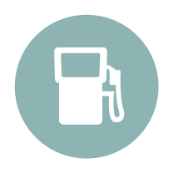

Worksheet

**Tank on empty?**

**Activity**

**What does stress look like for me? How do my thoughts, moods or behaviours change when I’m stressed or not coping?**

1. Think about when you notice stress in yourself, whether it’s a little thing or a big thing. What are some of the different things you notice about the way you feel (emotions), think, how your body reacts (physical) and the things you do (behaviours). Note these down.

|  |  |
| --- | --- |
| Changes in emotions/Taha wairua  (E.g. Getting startled, being afraid or anxious, anger and irritability, sadness, feeling inadequate) | Changes in thinking/Taha hinengaro  (E.g. Difficulty concentrating, remembering and following complex instructions, finding it harder to communicate, having intrusive thoughts) |
|  |  |
| Physical reactions/Taha tinana  (E.g. Tension, headaches, stomach upsets, sleeping badly, or sleeping too much, rapid heartbeat, shakiness, aches and pains) | **Changes in behaviour/Taha whānau**  (E.g. Withdrawing from others, using drugs or alcohol to cope, taking risks, stopping your favourite activities) |
|  |  |

1. Now look over your lists and highlight the ones you see as warning signs that tell me I should take action?